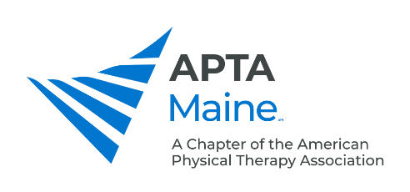

Student SIG organization/elected positions:

Student SIG Vice Chair:

Reports to: The Student SIG members; Maine APTA board of directors

Responsibilities:
    - Assume the duties of the Chairperson within the SSIG and in the event of his/her absence or inability to preside for any cause. Such as call, preside over, and approve agendas for all meetings of the SIG when the Chair is unavailable.
              - Serve as the official representative of the SIG, and be an advisory non-voting member of the Board of Directors and/or other Chapter committees on an as need basis.
    - Help organize events either fundraising or conferences during term of office.
    - Maintain and coordinate all necessary updating of the SSIG Policies and Procedures.
    - Keep records of the role and responsibilities of the Vice Chair to ease the transition to successor
    - Submit applicable reports from SIG meetings to the Chapter’s Board of Directors. i.e. annual SIG report
    - Orient and advise members of the SIG board regarding duties and responsibilities.
    - Oversee the goals/initiatives of the SIG.

Position Objectives:
Represents the Maine Chapter of the APTA Student SIG. Oversees the activities of the SIG under the direction of the Chair. Serves as a liaison between the SIG and the board of directors/Chapter president/chapter committees when the Chair is unavailable, or delegated by the SIG chair.

Qualifications:
Must fulfill qualification requirements outlined in the chapter bylaws. Must be available to participate in Board and membership meetings when called upon, as well as APTA meetings as needed.

Training and Evaluation:
You will be oriented by your predecessor and/or SIG chair along with a board liaison. You will be given the opportunity to provide feedback periodically on the functionality of the SIG. The goal of the evaluation process is to improve the function of the SIG and to provide personal and professional development for you.

